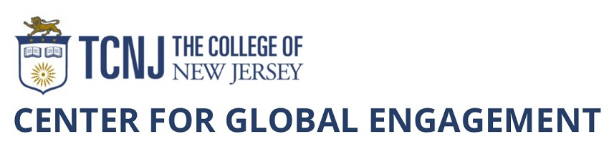

REQUEST TO SCHEDULE FACULTY-LED STUDY ABROAD PROGRAM
Deadline for Winter Session or Spring Break 2019: FEBRUARY 1, 2018
Deadline for Summer Session, Fall Break, or Thanksgiving 2019: MARCH 15, 2018

Program Information
Program Title:
Program location(s):
Requested program term:
Program Length (number of days):
Preferred Dates:
Cooperating institutions or organizations such as a Program Provider or foreign university or other on-site organization in the host country/countries:

When was program originally approved?

When did the program run previously and what were the enrollments?

Will there be changes in the locations where the program will run (i.e., changes in countries, regions, or cities)? Note: New locations may need to be approved by the Risk Mitigation & Crisis Management Working Group.

Will there be changes in the learning activities (ex. Including service learning or other activities designed to engage the local population)? Note: New activities may need to be approved by the Risk Mitigation & Crisis Management Working Group.

In our effort to understand the various ways faculty are integrating intercultural learning into their programs, please share some strategies you use to promote intercultural understanding and student reflection on their experiences.

Faculty Leader(s) Information
Faculty Leader 1 Name:
Telephone: Email:
Academic Department:

Faculty Leader 2 Name:
Telephone: Email:
Academic Department:

Chaperone Name:
Telephone: Email:
TCNJ Unit (if TCNJ employee):

Have the faculty leader(s) or chaperone led this program when it ran previously? Note: New faculty leaders and chaperones need to be approved by the Global Education Council.

Program Marketing and Recruitment
Note: It is the responsibility of the program leader(s) to promote the program with guidance and support from the Center for Global Engagement.
Which majors, minors, and other student groups do you intend to target while marketing your program?

What challenges do you expect in recruiting for this program?

Provide a brief summary of the program that can be used for the web site and other marketing materials. Include the academic topic, the location(s), excursions, cultural activities, and other highlights of the program (Summaries used in previous years can be modified and re-used).

SIGNATURES

Faculty Leader 1 Date

Department Chair 1 (required for Fall and Spring Break trips, optional for Winter and Date
Summer programs)

Dean 1 (required for Fall and Spring Break trips, optional for Winter and Summer programs) Date

Faculty Leader 2 Date

Department Chair 2 (required for Fall and Spring Break trips, optional for Winter and Date
Summer programs)

Dean 2 (required for Fall and Spring Break trips, optional for Winter and Summer programs) Date

Executive Director of Global Engagement Date

Please return the signed form to the Center for Global Engagement at cge@tcnj.edu by the appropriate deadline. The schedule for Winter Session and Spring Break programs for 2019 will be announced by March 15, 2018 and the schedule for Summer Session, Fall Break, and Thanksgiving Break programs for 2019 will be announced by May 1, 2018.

